Greetings to all Members and Friends of Pachaug Pond Weed Control Association,

I am writing this letter to reach out to you about the efforts of Pachaug Pond Weed Control Association (PPWCA) to fight a blight that presents a very real threat to Pachaug Pond and everyone’s ability to enjoy the lake. Pachaug Pond has a significant infestation of invasive weeds that will eventually reduce the quality and recreational value of the pond and potentially reduce the value of homes and land on the pond. We have been working closely with an invasive weed expert from the State of Connecticut Agricultural Experimental Station on this problem, and he has warned us that all lakes eventually die unless the vegetation in them is managed.
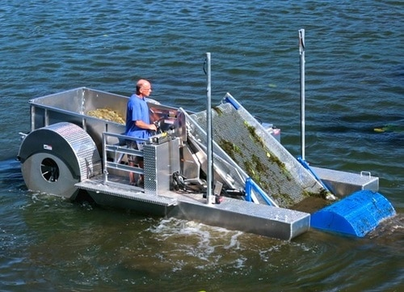
PPWCA is a non-profit 501 (c) (3) organization that has been operating for just over a year. We are committed to preserving Pachaug Pond for future generations and have embarked on an extensive study of strategies to control aquatic weeds. We believe weed control is possible by employing several different methods in a multi-pronged attack. One of the more effective solutions is removing the weeds with a mechanical harvester. This device collects the weeds by the roots and operates in as little as 18 inches of water allowing us to reduce both surface and sub-surface weed growth.

While weed harvesters are expensive, PPWCA has raised over $40,000 to date and has set a fund-raising goal for this initiative of $120,000. Along with numerous fund-raising events, we are sending out this letter to appeal for your donation towards the ECO Weed Harvester.

Any amount will help us attack the ever-growing weed problem in Pachaug Pond, and we urge you to consider becoming a sponsor.
Platinum sponsor – Over $2,000
Gold sponsor – Between $1,001 and $2,000
Silver sponsor – Between $500 and $1,000
Bronze sponsor – Under $500

Tax-deductible donations can be made through our website or by check payable to PPWCA sent to:
Barbara Hatch, Treasurer PPWCA
142 Mackin Drive, Griswold CT 06351

Please consider a contribution that will help to protect Pachaug Pond.

Sincerely,
Thomas Giard, Jr., President

